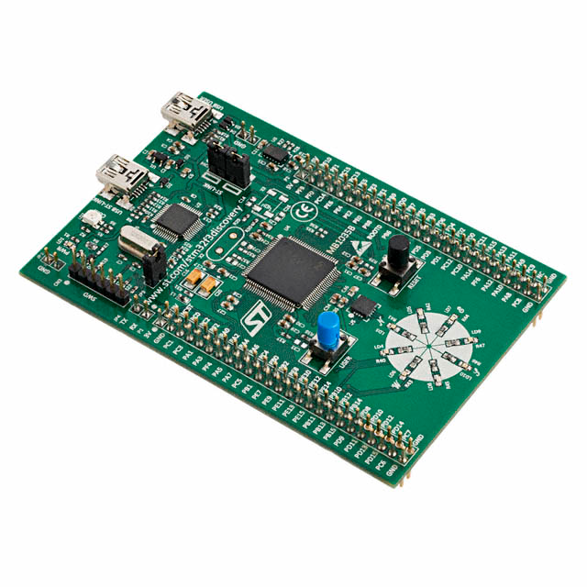 | COMPUTER SCIENCE DEPARTMENT  TE2004B – ADVANCED EMBEDDED SYSTEMS DESIGN  LAB #3 – FIR Filter
 | Name: _________________________  ID: _________________________ | Name: _________________________  ID: _________________________
 | Name: _________________________  ID: _________________________ | Name: _________________________  ID: _________________________

Instructions:

Section 1: Unit impulse response

- Configure a function generator with the following parameters:

  - Wave: Sine
  - Frequency: 1 Hz
  - Amplitude: 1.25 V
  - Offset: 1.5 V

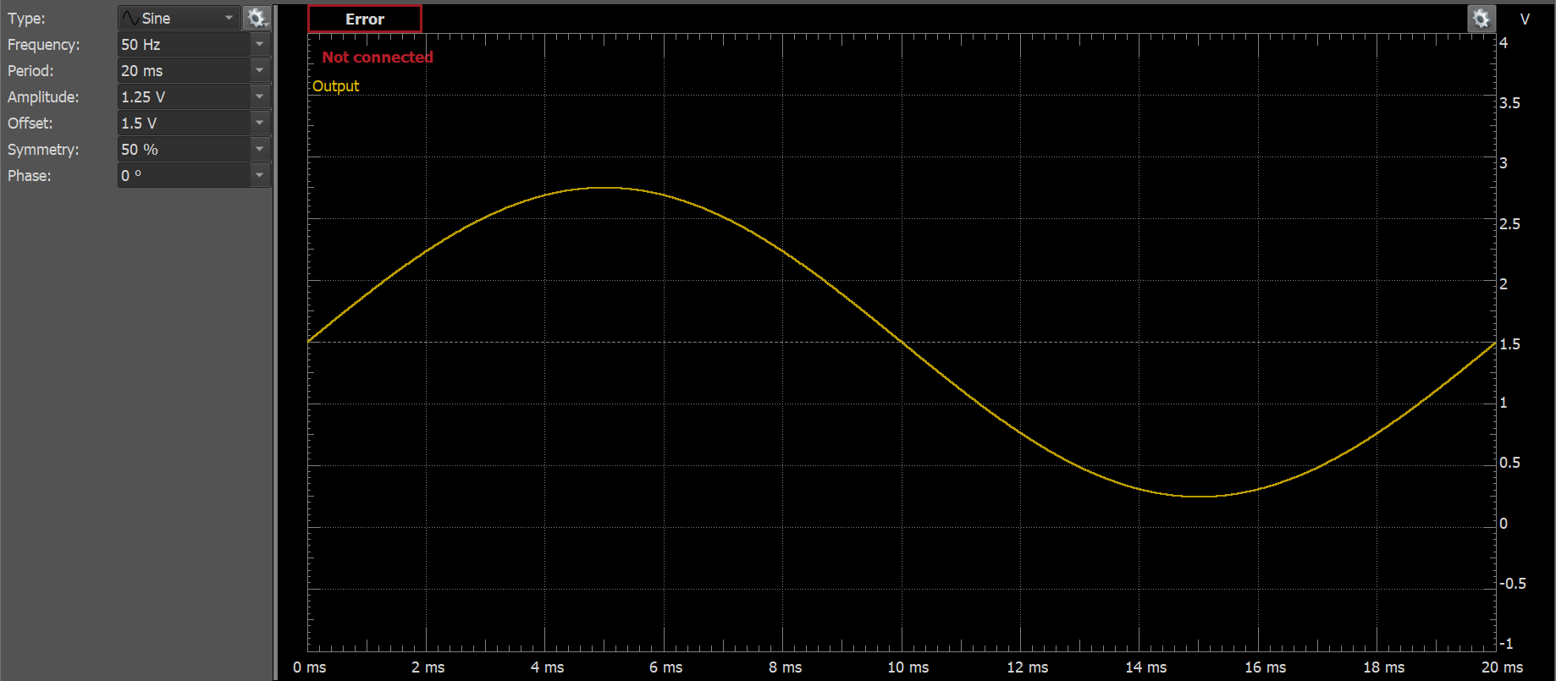
Figure 1.1. Function generator signal

Connect the function generator to the oscilloscope (via channel 1) in order to verify the correctness of the required signal. Skipping this step can result in damaging the STM32H533RE-NUCLEO board.

- Connect the output of the function generator to both the oscilloscope (via channel 1) and to the board’s PA6 pin. Then connect another channel of the oscilloscope to the board’s PA5 pin.

- Generate a new project with a 240MHz clock signal and replace the main function with the program in Listing 1.1.

Listing 1.1. Code for problem #X
uint16_t ADCRead( void );

int main(void)
{
HAL_Init();
SystemClock_Config();
MX_GPIO_Init();

RCC->AHB2ENR |= RCC_AHB2ENR_GPIOBEN;
GPIOB->MODER = (GPIOB->MODER & ~GPIO_MODER_MODE2) | GPIO_MODER_MODE2_0;

RCC->AHB2ENR |= RCC_AHB2ENR_GPIOAEN;
GPIOA->MODER |= GPIO_MODER_MODE6_0;

RCC->CFGR2 &= ~RCC_CFGR2_HPRE_3;
RCC->AHB2ENR |= RCC_AHB2ENR_ADCEN;

ADC12_COMMON->CCR |= ADC_CCR_CKMODE_0;
ADC1->CR &= ~ADC_CR_DEEPPWD;
ADC1->CR &= ~ADC_CR_ADVREGEN;
ADC1->CR |= ADC_CR_ADVREGEN;

ADC1->CR |= ADC_CR_ADCAL;
while( ADC1->CR & ADC_CR_ADCAL );

ADC1->CFGR &= ~ADC_CFGR_RES;
ADC1->CFGR &= ~ADC_CFGR_ALIGN;
ADC1->CFGR &= ~ADC_CFGR_CONT;

ADC1->SQR1 &= ~ADC_SQR1_L;
ADC1->SQR1 |= 3U<<ADC_SQR1_SQ1_Pos;

ADC1->SMPR1 &= ~ADC_SMPR1_SMP3;

ADC1->CR |= ADC_CR_ADEN;
while( !( ADC1->ISR & ADC_ISR_ADRDY ) );

RCC->AHB2ENR |= RCC_AHB2ENR_GPIOAEN;
GPIOA->MODER |= GPIO_MODER_MODE5;
RCC->AHB2ENR |= RCC_AHB2ENR_DAC1EN;
DAC1->CR |= DAC_CR_EN2;

RCC->APB1LENR |= RCC_APB1LENR_TIM2EN;
TIM2->PSC = 1 - 1;
TIM2->ARR = 24e6 - 1;
TIM2->CNT = 0;
TIM2->DIER |= TIM_DIER_UIE;
NVIC_EnableIRQ(TIM2_IRQn);
__enable_irq();
TIM2->CR1 |= TIM_CR1_CEN;

while (1)
{
uint16_t x = ADCRead();
DAC1->DHR12R2 = x;
}
}

void TIM2_IRQHandler(void)
{
// Number of elements in input vector and filter
int32_t K = 3;

// Inputs vector
static float X[3] = {};

// Filter coefficients
static float B[3] = {1.0, 0.0, 0.0};

// Output per sample
float y = 0.0;

// Index of new input sample
static int32_t xZero = 0;

// Counter for the number of elements in the inputs vector
int32_t k = 0;

TIM2->SR &= ~TIM_SR_UIF;
GPIOB->ODR |= GPIO_ODR_OD2;

X[xZero] = (float)ADCRead(); // Save the new sample into the zero of the inputs vector
y = 0.0;
for( k=0; k<K; k++ ) // Make convolution between the filter vector and inputs vector
{
y += X[xZero]*B[k];
if( --xZero < 0 ) // Traverse circularly the inputs vector.
// If going before the index zero, set index
// to the greatest one inside the vector
{
xZero = K - 1;
}
}
if( ++xZero > K - 1 ) // Set a new xZero value in order to save next sample
// If going after the greatest index in the array, set
// index to zero
{
xZero = 0;
}

if(y > 4095.0)
y = 4095.0;
else if(y < 0.0)
y = 0.0;

DAC1->DHR12R2 = (uint16_t)y;

GPIOB->ODR &= ~GPIO_ODR_OD2;
}

uint16_t ADCRead( void )
{
ADC1->CR |= ADC_CR_ADSTART;
while( !( ADC1->ISR & ADC_ISR_EOC ) );

return ADC1->DR & 0xFFF;
}

- Take a picture of the oscilloscope output.

Picture 1.1. Screenshot for the unit impulse response

Section 2: FIR filter response

- In https://fiiir.com/ compute the coefficients of a filter with the following characteristics:

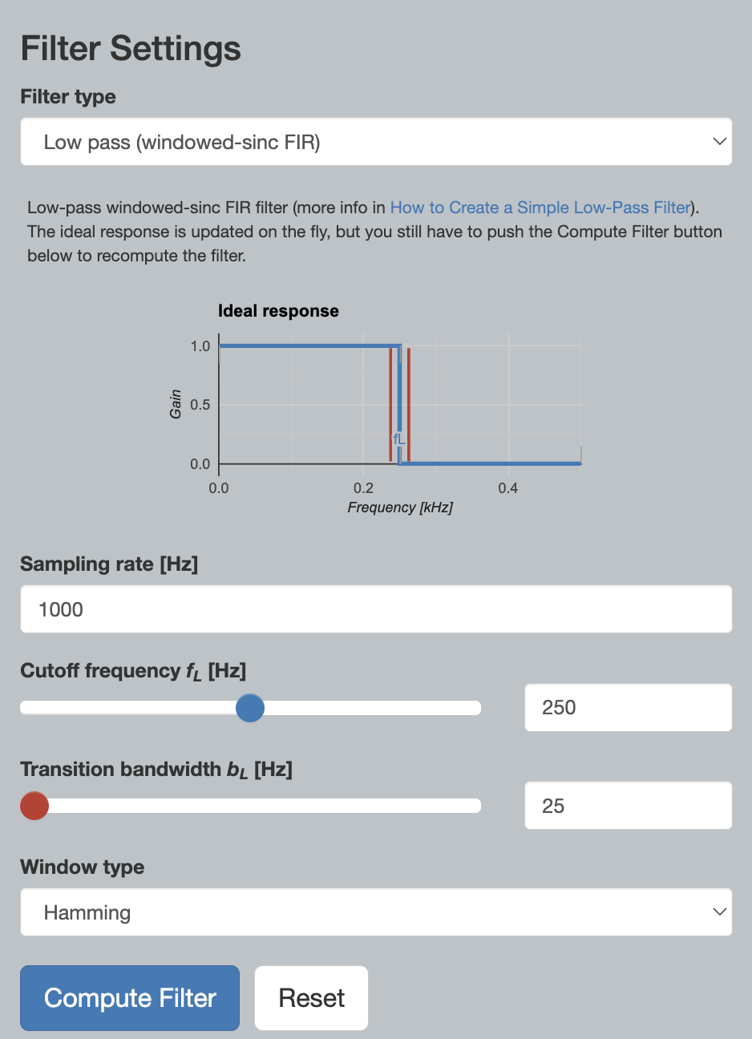
Figure 2.1. FIR filter coefficients

- Include the computed coefficients into the STM32CubeIDE project. Adapt the sampling frequency accordingly. Take a screenshot of the output of the oscilloscope both for a signal in the passband region and a signal in the stopband region:

Picture 2.1. Screenshot for the FIR filter response using a signal in the passband region

Picture 2.2. Screenshot for the FIR filter response using a signal in the stopband region

- Explain how the FIR filter implementation from the project works:
Listing 2.1. Description for the FIR filter program

